HW2 Screenshots

1. Original database before inserting new items
2. 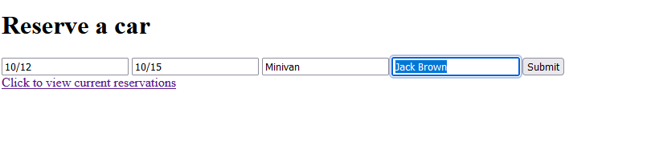A computer screen shot of a computer

   Description automatically generated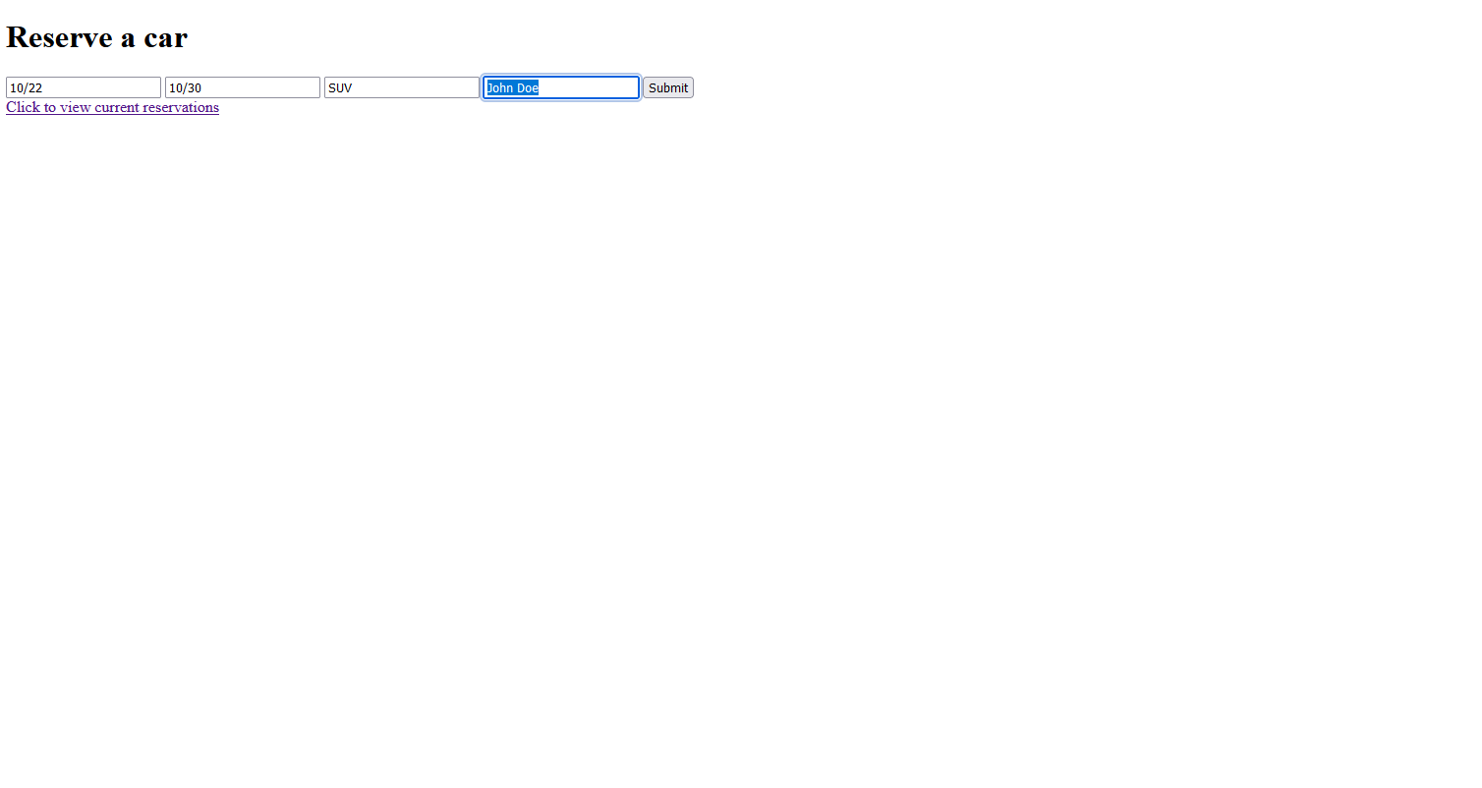Inserting new items into database (click submit button on webpage to add entry)
3. Database after inserting new entries

1. Click on the link to jumA screenshot of a computer

   Description automatically generatedp to the next page
2. A close-up of a reservation

   Description automatically generatedClick on “Show all reservations button” to view all current reservations